Atonement

Heart of Evangelicalism

Define Atonement – propitiation
expiation

Larger context: sacrifice-establish, mainatain, or restore a right relationship to the sacred- Britannica: gift to secure favour, minimalize hostility, communion among clan, bond to sacred ally
rejuvinating a god by slaying king; gift that forges a 2 way bond
DeVaux pg 447: gift to malevolant deity?, seek benefit?, union with deity by magic- represents self
meal for gods?, rebuttals from Ps 50:12-13
OT- gift, union, expiation, and more
tribute-desacralizes everything else for own use, needs to support life, given irrevocably to God- not chiefly to destroy it. 'olah- to bring near, to make rise up, to offer
communion- eat the sacrifice to share in what Yahweh has accepted on the altar
expaiation
Prophetic polemic against sacrifices- 1 Sam 15:22- obey is better Prov 15:8 sacrifice of wicked is abomination. Jeremiah & Ezekiel – heart matters, sacrifice is outward expession of inward disposition
OT on sacrifice – gift , given in worship, substance on which human life depends is given irrevokably
      - cleansing, purification
      - reparation
      - offered by man; offered unto God
      - in place of righteous punishement
      - ineffecual and void without genuine repentance
      - most sins are unconcious, we are guilty without knowing it and held responsible
Sacrifice of Isaac – the Akedah
        - worship,
        - test of faith, act violates channel of promise - Kierkegaard
        - age of Isaac, the Father of Faith sacrifices child of Promise
        - Abraham did not know that God would raise Isaac, only deduced that he could
The impossible necessity- beloved son must live; beloved son must be offered up

Resolution? Messiah Ben Joseph- suffering one, Messiah Ben David – victorious one
Servant Songs – humiliation & suffering , triumph and exaltation of the Servant
-Isaiah 53 study
---------------------------------------------------------------------------------------------------------
Fresh cut flowers or plants? Which bespeaks devotion?

4. Significance of Burnt Offering (holocaust)
a. A gift to God
b. Seen as the most valuable kind of sacrifice
c. It seems to deal with the concept of sin in general or thanksgiving
d. Most perfect representation of sacrificial idea
e. Symbolic offering of one's life
f. Represents complete consecration of the life of an individual to the service of God
g. Graded value of offering- bull, sheep/goat, birds
h. This shows that anyone conscious of spiritual need could approach God. God made provision for all men.

Passover – springtime meal of lamb celebrated among Semetic peoples – predates Exodus
redemption of firstborn act by which God takes people to himself
    - covenant of blood – painted upon doorway– participation by eating
    - lifeblood given in exchange for life of firstborn
    - judgement of the oppressors, protection of the redeemed

Sin – rebellion against God --defamation of his image Gen 9:6
“Whatever weakens your reason, impairs the tenderness of your conscience, obscures your sense of God, takes off your relish for spiritual things, whatever increases the authority of the body over the mind, that thing is sin to you, however innocent it may seem in itself.” ― Susanna Wesley

D. Leviticus 4:1-5:13 (6:24-30), Purification (sin) offering (hatta'th)
a. This is the first offering in which atonement was the dominant element.
b. This sacrifice re-establishes the covenant between man and God. It restores fellowship.
c. This offering involves:
(1) Sins of ignorance (2) Sins of inadvertence (3) Sins of passion (4) Sins of omission
(5) It did not atone for sins committed intentionally in haughty rebellion against God. There was no sacrifice for intentional, high handed, premeditated sin ( Num. 15:27-31).
2. Meaning
a. This offering expiated the guilt and punishment for sins.
b. This involved grace on God's part and faith on man's part.
c. No sacrifice achieves anything by mere ritual offering. It was the offerer's faith behind the act.
d. Yet, sacrifice was more than the mere expression of the offerer. It did something for him. It re-established the relationship with God.
e. Ritual was a God-given means of restitution, not a substitute for personal faith.
f. God hates any religious action without accompanying faith, Isa. 1:10-20; Amos 5:21-24; Micah 6:6-8.

E. Leviticus 5:14-19, Guilt or trespass or reparation offering ('asham)
1. Introduction
a. While the Sin Offering dealt with sin committed, the Guilt Offering had to do with the damage that was done to a covenant partner and what restitution was possible.
b. The sin and trespass offerings were very similar.

c. The rights of the individual were expressed in the Ten Commandments (Exodus 20; Deuteronomy 5).
(1) home (2) accumulation of good (3) life
d. This offering emphasizes the harm done to a brother in sinning, & the restitution of the cost of damages + 1/5th Zacchias
2. Sins Requiring an Offering
a. against God or that which belongs to Him
(1) first fruits
(2) firstborn, Lev. 5:14-16
(3) tithe
(4) offering given incorrectly
(5) gifts of inferior value
b. "If a person sins and does any of the things which the Lord has commanded not to be done, though he was unaware, still he is guilty, and shall bear his punishment."

Atonement as Impossible Necessity – Micah 6 With what shall i come before the Lord, with 10,000 rivers of oil?

The double cure of 'Rock of Ages'

Various theories of Atonement

The Ransom Theory: The earliest of all, originating with the Early Church Fathers, this theory claims that Christ offered himself as a ransom (Mark 10:45). Where it was not clear was in its understanding of exactly to whom the ransom was paid. Many early church fathers viewed the ransom as paid to Satan.
- The Recapitulation Theory: Originated with Irenaeus (125-202 AD). He sees Christ as the new Adam, who systematically undoes what Adam did. Thus, where Adam was disobedient concerning God's edict concerning the fruit of the Tree of Knowledge, Christ was obedient even to death on the wood of a tree. Irenaeus is the first to draw comparisons between Eve and Mary, contrasting the faithlessness of the former with the faithfulness of the latter. In addition to reversing the wrongs done by Adam, Irenaeus thinks of Christ as "recapitulating" or "summing up" human life. See main page on Recapitulation theory of atonement
- The Satisfaction (or Commercial) Theory: The formulator of this theory was the medieval theologian Anselm of Canterbury (1034-1109), in his book, Cur Deus Homo (lit. Why the God Man). In his view, God's offended honor and dignity could only be satisfied by the sacrifice of the God-man, Jesus Christ. "Anselm offered compelling biblical evidence that the atonement was not a ransom paid by God to the devil but rather a debt paid to God on behalf of sinners."^ [1]^ Anselm's work established a foundation for the Protestant Reformation, specifically the understanding of justification by faith. See main page on Satisfaction theory
- The Penal-Substitution Theory: This view was formulated by the 16th century Reformers as an extension of Anselm's Satisfaction theory. Anselm's theory was correct in introducing the satisfaction aspect of Christ's work and its necessity, however the Reformers saw it as insufficient because it was referenced to God's honor rather than his justice and holiness and was couched more in terms of a commercial transaction than a penal substitution. This Reformed view says simply that Christ died for man, in man's place, taking his sins and bearing them for him. The bearing of man's sins takes the punishment for them and sets the believer free from the penal demands of the law: The righteousness of the law and the holiness of God are satisfied by this substitution. See main page on Penal substitution theory
- The Moral-Example Theory (or Moral-Influence Theory): Christ died to influence mankind toward moral improvement. This theory denies that Christ died to satisfy any principle of divine justice, but teaches instead that His death was designed to greatly impress mankind with a sense of God's love, resulting in softening their hearts and leading them to repentance. Thus, the Atonement is not directed towards God with the purpose of maintaining His justice, but towards man with the purpose of persuading him to right action. Formulated by Peter Abelard (1079-1142) partially in reaction against Anselm's Satisfaction theory, this view was held by the 16th century Socinians. Versions of it can be found later in F. D. E. Schleiermacher (1768-1834) and Horace Bushnell (1802-1876). See main page on Moral Influence theory
- The Governmental Theory: God made Christ an example of suffering to exhibit to erring man that sin is displeasing to him. God's moral government of the world made it necessary for him to evince his wrath against sin in Christ. Christ died as a token of God's displeasure toward sin and it was accepted by God as sufficient; but actually God does not exact strict justice. This view was formulated by Hugo Grotius (1583-1645) and is subsequently found in Arminianism, Charles Finney, the New England Theology of Jonathan Edwards (the younger), and Methodism. See main page on Governmental theory of atonement

Modern theories The Declaratory Theory: The Guaranty Theory: The Vicarious Repentance
- The 'Christus Victor' or Dramatic Theory: by G. E. H. Aulén (1879-1977). The atonement is viewed as divine conflict and victory over the hostile powers that hold humanity in subjection. This is a modified form of the classic Ransom theory with the emphasis on Christ's victory over evil. See main article Christus Victor.

The Gospel according to St. Paul

Romans: Paul puts Jews and Gentiles on even ground before the Gospel - Jews return

God presented Christ as a sacrifice of atonement, through the shedding of his blood—to be received by faith. He did this to demonstrate his righteousness, because in his forbearance he had left the sins committed beforehand unpunished— Rom 3:25

For this reason he had to be made like them, fully human in every way, in order that he might become a merciful and faithful high priest in service to God, and that he might make atonement for the sins of the people. Heb 2:17

IMy concerns: is the NT true to the OT . i.e. Do the Law and the Prophets truly point to Christ and his atonement as the centre of God’s message and our hope for deliverance?

What are the larger metaphors that cannot be separated from the Gospel?

In which direction does our presentation of the Gospel get distorted by culture?

Repugnant caracatures of the Atonement - a merciful Christ before a stern Father
- badminton illustration

The image of God; no other creature made to mirror him - story of Nebuchadnezzer, Darius

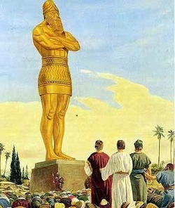

Sin as addiction, misrepresented as irresitable pleasures;
Don’t magnify the seriousness of individual sins- consider Sin, and where it leads…
Murder punishable by death because the human is God’s image Gen 9:6
http://listverse.com/2013/08/05/10-brutal-atrocities-people-continue-to-defend/
http://www.truthbeknown.com/victims.htm
http://list25.com/25-most-brutal-torture-techniques-ever-devised/
http://www.hiddenhurt .co.uk/danna_physical_abuse_story.html
http://us.reachout.com/real-stories/self-harm

Victims of adultery, parents of murderers - pain is felt inside a person.
‘His wrath is his love burning hot’ -Luther
Most people don’t understand that God’s wrath is completely justified- Prof. Jacob Yatch
If for one minute you felt what God feels, you would go insane

Atonement in Paul

How does Paul speak of the work of Christ?
How does he understand the way we need to appropriate it for ourselves ?
What Old Testatment understandings does Paul have in mind?

3:23for all have sinned and fall short of the glory of God, 24and all are justified freely by his grace through the redemption that came by Christ Jesus. 25God presented Christ as a sacrifice of atonement,^{i} through the shedding of his blood—to be received by faith. He did this to demonstrate his righteousness, because in his forbearance he had left the sins committed beforehand unpunished— 26he did it to demonstrate his righteousness at the present time, so as to be just and the one who justifies those who have faith in Jesus.

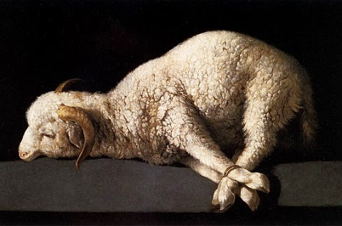

4:24 to whom God will credit righteousness—for us who believe in him who raised Jesus our Lord from the dead. 25He was delivered over to death for our sins and was raised to life for our justification.

5:6You see, at just the right time, when we were still powerless, Christ died for the ungodly. 7Very rarely will anyone die for a righteous person, though for a good person someone might possibly dare to die. 8But God demonstrates his own love for us in this: While we were still sinners, Christ died for us.
9Since we have now been justified by his blood, how much more shall we be saved from God’s wrath through him! 10For if, while we were God’s enemies, we were reconciled to him through the death of his Son, how much more, having been reconciled, shall we be saved through his life! 11Not only is this so, but we also boast in God through our Lord Jesus Christ, through whom we have now received reconciliation.

Consequently, just as one trespass resulted in condemnation for all people, so also one righteous act resulted in justification and life for all people. 19For just as through the disobedience of the one man the many were made sinners, so also through the obedience of the one man the many will be made righteous.

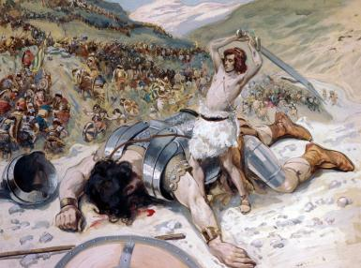
David’s victory is the rallying call for all those he represents to charge in and fight, assured of their own victory. Christ’s victory is not merely to be gazed upon with wonder. We also are called to join his fight.

6:1 What shall we say, then? Shall we go on sinning so that grace may increase? 2By no means! We are those who have died to sin; how can we live in it any longer? 3Or don’t you know that all of us who were baptized into Christ Jesus were baptized into his death? 4We were therefore buried with him through baptism into death in order that, just as Christ was raised from the dead through the glory of the Father, we too may live a new life.
5For if we have been united with him in a death like his, we will certainly also be united with him in a resurrection like his. 6For we know that our old self was crucified with him so that the body ruled by sin might be done away with,ª that we should no longer be slaves to sin— 7because anyone who has died has been set free from sin.
8Now if we died with Christ, we believe that we will also live with him. 9For we know that since Christ was raised from the dead, he cannot die again; death no longer has mastery over him. 10The death he died, he died to sin once for all; but the life he lives, he lives to God.
11In the same way, count yourselves dead to sin but alive to God in Christ Jesus. 12Therefore do not let sin reign in your mortal body so that you obey its evil desires. 13Do not offer any part of yourself to sin as an instrument of wickedness, but rather offer yourselves to God as those who have been brought from death to life; and offer every part of yourself to him as an instrument of righteousness.

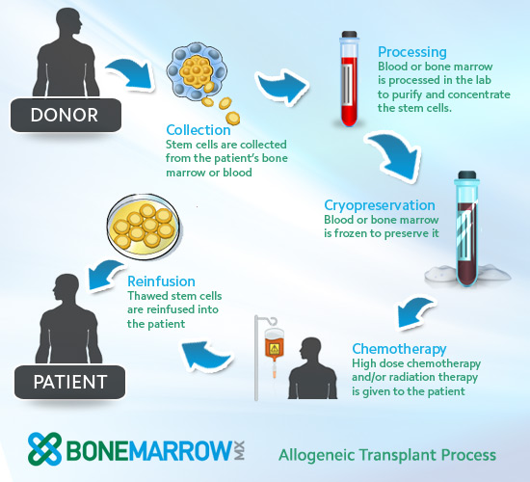

One process for wiping out leukemia- destroy all cancerous white blood cells ( death)
before reinfusion of life-giving stem cells from healthy donor.
We can benefit from Christ’s blood only as we join him in death, so that we are united to him in life

4So, my brothers and sisters, you also died to the law through the body of Christ, that you might belong to another, to him who was raised from the dead, in order that we might bear fruit for God. 5For when we were in the realm of the flesh,ª the sinful passions aroused by the law were at work in us, so that we bore fruit for death. 6But now, by dying to what once bound us, we have been released from the law so that we serve in the new way of the Spirit, and not in the old way of the written code.

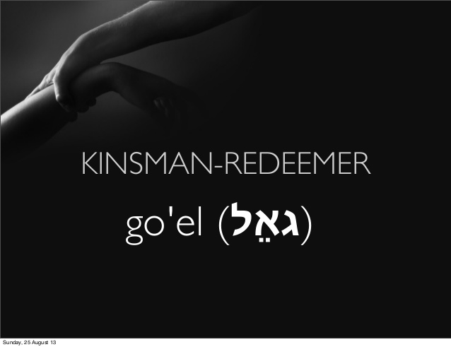

Boaz doesn’t just pay the price of redemption. He does so in order to marry the widow Ruth, raise up children and so deliver her from her state of barenness - a fate worse than death in Israel.

3For what the law was powerless to do because it was weakened by the flesh,^{b} God did by sending his own Son in the likeness of sinful flesh to be a sin offering.^{c} And so he condemned sin in the flesh, 4in order that the righteous requirement of the law might be fully met in us, who do not live according to the flesh but according to the Spirit.

Israel’s unbelief - mercy flows to Gentiles

A Living Sacrifice
1Therefore, I urge you, brothers and sisters, in view of God’s mercy, to offer your bodies as a living sacrifice, holy and pleasing to God—this is your true and proper worship. 2Do not conform to the pattern of this world, but be transformed by the renewing of your mind. Then you will be able to test and approve what God’s will is—his good, pleasing and perfect will.

1 Corinthians 3For what I received I passed on to you as of first importanceª : that Christ died for our sins according to the Scriptures, 4that he was buried, that he was raised on the third day according to the Scriptures,

If song lyrics reflect popular understaning of our reponse to the word of the cross, what does this say about our working theology?

https://songselect.ccli.com/search/results?List=popular

2 Corinthians 14For Christ’s love compels us, because we are convinced that one died for all, and therefore all died. 15And he died for all, that those who live should no longer live for themselves but for him who died for them and was raised again.
16So from now on we regard no one from a worldly point of view. Though we once regarded Christ in this way, we do so no longer. 17Therefore, if anyone is in Christ, the new creation has come:ª The old has gone, the new is here! 18All this is from God, who reconciled us to himself through Christ and gave us the ministry of reconciliation: 19that God was reconciling the world to himself in Christ, not counting people’s sins against them. And he has committed to us the message of reconciliation. 20We are therefore Christ’s ambassadors, as though God were making his appeal through us. We implore you on Christ’s behalf: Be reconciled to God. 21God made him who had no sin to be sin^{b} for us, so that in him we might become the righteousness of God.

Galatians: True Gospel elevates believers status, no longer slaves but Sons
2:20 I have been crucified with Christ and I no longer live, but Christ lives in me. The life I now live in the body, I live by faith in the Son of God, who loved me and gave himself for me.
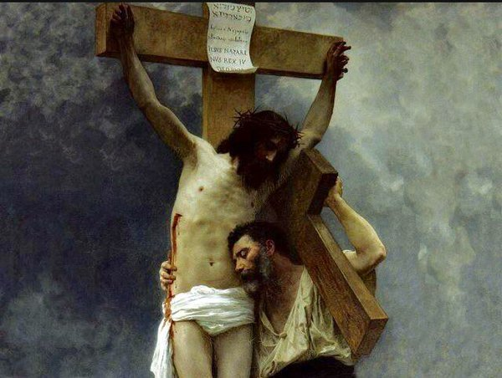

He bears my sin and my judgement; he does not bear my cross- his cross appoints me to my own cross, which I must bear as I follow him wherever he leads.

Ephesians: Delivered us in order to lavish upon us every possible blessing in Christ: For he chose us in him before the creation of the world to be holy and blameless in his sight. In love 5 he[b]predestined us for adoption to sonship[c] through Jesus Christ, in accordance with his pleasure and will— 6 to the praise of his glorious grace, which he has freely given us in the One he loves. 7 In him we have redemption through his blood, the forgiveness of sins, in accordance with the riches of God’s grace 8 that he lavished on us. With all wisdom and understanding,

6:26 Christ loved the church and gave himself up for her 26to make her holy, cleansing^{b} her by the washing with water through the word, 27and to present her to himself as a radiant church, without stain or wrinkle or any other blemish, but holy and blameless.



Phillipians: Obedient in suffering - Imitating Christ’s humility x4 examples
Passion to know Christ in the fellowship of his suffering, becoming like him in death, and then the power of his resurrection

Colosians: 1:12 joyful thanks to the Father, who has qualified you[f] to share in the inheritance of his holy people in the kingdom of light. 13 For he has rescued us from the dominion of darkness and brought us into the kingdom of the Son he loves, 14 in whom we have redemption, the forgiveness of sins.

19 For God was pleased to have all his fullness dwell in him, 20 and through him to reconcile to himself all things, whether things on earth or things in heaven, by making peace through his blood, shed on the cross.
21 Once you were alienated from God and were enemies in your minds because of[g] your evil behavior. 22 But now he has reconciled you by Christ’s physical body through death to present you holy in his sight, without blemish and free from accusation—
2:13 When you were dead in your sins and in the uncircumcision of your flesh, God made you[d] alive with Christ. He forgave us all our sins, 14 having canceled the charge of our legal indebtedness, which stood against us and condemned us; he has taken it away, nailing it to the cross. 15 And having disarmed the powers and authorities, he made a public spectacle of them, triumphing over them by the cross.[e]


3:1Since, then, you have been raised with Christ, set your hearts on things above, where Christ is, seated at the right hand of God. 2 Set your minds on things above, not on earthly things. 3 For you died, and your life is now hidden with Christ in God. 4 When Christ, who is your[a] life, appears, then you also will appear with him in glory.


2 Timothy 2:2 11 Here is a trustworthy saying:If we died with him, we will also live with him;12 if we endure, we will also reign with him.If we disown him, he will also disown us;13 if we are faithless, he remains faithful, for he cannot disown himself.
Titus 2:11 For the grace of God has appeared that offers salvation to all people. 12 It teaches us to say “No” to ungodliness and worldly passions, and to live self-controlled, upright and godly lives in this present age, 13 while we wait for the blessed hope—the appearing of the glory of our great God and Savior, Jesus Christ, 14 who gave himself for us to redeem us from all wickedness and to purify for himself a people that are his very own, eager to do what is good.
3:4 he saved us, not because of righteous things we had done, but because of his mercy. He saved us through the washing of rebirth and renewal by the Holy Spirit, 6 whom he poured out on us generously through Jesus Christ our Savior, 7 so that, having been justified by his grace, we might become heirs having the hope of eterna life.

Hebrews 5:8 Son though he was, he learned obedience from what he suffered 9 and, once made perfect, he became the source of eternal salvation for all who obey him
Heb 9:1111 But when Christ came as high priest of the good things that are now already here,[a] he went through the greater and more perfect tabernacle that is not made with human hands, that is to say, is not a part of this creation. 12 He did not enter by means of the blood of goats and calves; but he entered the Most Holy Place once for all by his own blood, thus obtaining[b] eternal redemption. 13 The blood of goats and bulls and the ashes of a heifer sprinkled on those who are ceremonially unclean sanctify them so that they are outwardly clean. 14 How much more, then, will the blood of Christ, who through the eternal Spirit offered himself unblemished to God, cleanse our consciences from acts that lead to death,[c] so that we may serve the living God!
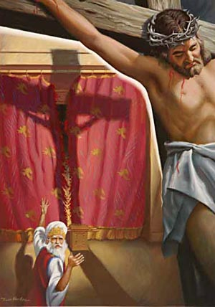 Story of the Rabbi who came to Tyndale
How can Jesus be the sin offering? He was not sacrificed at the temple, his blood was never applied in the sanctuary.
11The high priest carries the blood of animals into the Most Holy Place as a sin offering, but the bodies are burned outside the camp. 12And so Jesus also suffered outside the city gate to make the people holy through his own blood. 13Let us, then, go to him outside the camp, bearing the disgrace he bore. 14For here we do not have an enduring city, but we are looking for the city that is to come.

Johannine witness; Gospel of John, 1 John
Answer to the challenge: Paul changed the message of the Kingdom of God in the gospels and reinterpreted it as the message of personal salvation through faith in Christ’s atonement.
Why do we preach the gospel from the letters of Paul, rarely ever from the gospels.

Direct and indirect communication
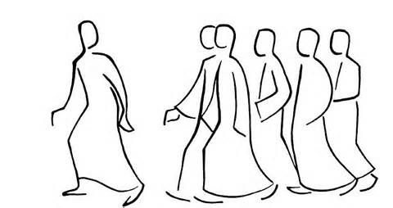

http://commons.nmu.edu/cgi/viewcontent.cgi?article=1317&context=facwork

How does Indirect Communication Work?
The point of indirect communication is to position the reader to relate to the truth with appropriate passion, rather than to communicate the truth as such. Kierkegaard almost always talks about indirect communication in situations where the learner must appropriate the content of the communication into how he or she lives his or her life. Anti-Climacus states that the indirect communicator does not tell the learner exactly what the outcome of the learning process is supposed to be. Instead, the indirect communicator provides the learner with a puzzle or problem that the learner must figure out for himself or herself (PC, 133; cf. CUP, 1:242). Pseudonymity. However, it is not the only device on the list. Kierkegaard also includes deception, humor, irony, ambiguity, fictional narratives, and “imaginative constructions.”16

Why is Indirect Commnication Make us Anxious?
People frequently lack the courage to make a decision—especially one having to do with ethics and religion—without simply deferring to public opinion on the matter.2 First, if you make a decision for yourself, you might not end up making the same decision as other people. You therefore might not enjoy the natural comfort that comes with human solidarity (JP, 4:4885). Moreover, you might experience the discomfort of persecution or peer pressure (TSI, 120; UDVS, 136). After all, other people also want to enjoy the comfort of solidarity. If you do not share their opinion, you inhibit them from enjoying this comfort fully. Thus, they will be well-motivated to pressure you into conforming to their views. Second, if you make decisions for yourself, you bear the responsibility for those decisions (UDVS, 132-33). Thus if you happen to decide wrongly, you will be subject to blame. The blame might come from other people. But, even more frightfully, it might come from God or from yourself in the form of the voice of conscience (UDVS, 128-29).

Direct communication leads to us mastering the message, knowing vs acting, in control, static.
The language of science, engineering, government and policy, rules.
Indirect communication leads to us being mastered by the message, knowing through acting, obedient, dynamic.
The language of literature, love, identity, meaning, life - metaphor, parable, poetry, story
Story of Aaron, smoking.

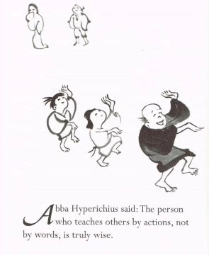

Word became flesh- formula for understanding Jn

Jesus Calls the First Disciples -come and see

Jesus at the Feast of Booths

7 After this Jesus went about in Galilee. He would not go about in Judea, because the Jews[a] were seeking to kill him. 2 Now the Jews' Feast of Booths was at hand. 3 So his brothers[b] said to him, “Leave here and go to Judea, that your disciples also may see the works you are doing. 4 For no one works in secret if he seeks to be known openly. If you do these things, show yourself to the world.”5 For not even his brothers believed in him. 6 Jesus said to them, “My time has not yet come, but your time is always here. 7 The world cannot hate you, but it hates me because I testify about it that its works are evil. 8 You go up to the feast. I am not[c] going up to this feast, for my time has not yet fully come.” 9 After saying this, he remained in Galilee.

10 But after his brothers had gone up to the feast, then he also went up, not publicly but in private. 11 The Jews were looking for him at the feast, and saying, “Where is he?” 12 And there was much muttering about him among the people. While some said, “He is a good man,” others said, “No, he is leading the people astray.” 13 Yet for fear of the Jews no one spoke openly of him.

14 About the middle of the feast Jesus went up into the temple and began teaching. 15 The Jews therefore marveled, saying, “How is it that this man has learning,[d] when he has never studied?” 16 So Jesus answered them, “My teaching is not mine, but his who sent me. 17 If anyone's will is to do God's[e] will, he will know whether the teaching is from God or whether I am speaking on my own

Jesus Feeds the Five Thousand

I Am the Bread of Life- eat his flesh and drink his blood

I Am the Light of the World

Jesus Heals a Man Born Blind- singled out

-----------------------------------------------------------------------------------------------------------------------------------------

http://exegeticalnotes.blogspot.ca/2011/03/wedding-theme-in-gospel-of-john.html

The Wedding at Cana- bridgeroom provides wine

John the Baptist Exalts Christ- bridegroom’s friend

Jesus and the Woman of Samaria -wedding imagery

SUNDAY, MARCH 20, 2011

The wedding theme in the gospel of John
The ideal marriage gives a new, richer life brimming over with joy. John uses this as a metaphor for eternal life, the new kind of life that comes through relationship with Jesus. I think this metaphor is much more tightly woven into the tapestry of the gospel of John than most people have realized. This attempts to lay out some of the connections. Probably not everyone will agree with everything in here.

The first place where the wedding theme crops up is in John 2, when Jesus is invited to a wedding. The wine has run out. It was the responsibility of the groom to provide the wine (we know this from external evidence, and also from 2:10). Providing the wine was a large responsibility, because a wedding feast could go on for days and involve the whole town. His mother, who is probably there in some semi-official capacity, perhaps because she is a relation, asks him to help solve the problem. It is not clear from the text exactly what she was expecting, but I think it is unlikely that she was asking him to perform a miracle (though many interpreters have thought she was). More likely, she was assuming he would go somewhere to fetch more wine and would need the servants' help to bring it back.
What is particularly interesting is Jesus reply to her: "My hour is not yet come." If it were not for the use of that phrase in the rest of the gospel of John (see below on this), we would probably assume that he was saying, "This isn't my wedding--it's not my time to provide the wine." It is the bridegroom whose hour has come. Despite this, however, he does provide the wine, of surpassingly good quality. What are we to make of this?
The point of the story is not just that he performed a miracle. Note that the miraculous nature of it is de-emphasized--the miracle is buried in a dependent clause in 2:9, and apparently it is not at all dramatic; it reveals Jesus' glory only through later reflection. John calls it a "sign", and signs in the gospel of John are never merely demonstrations of power. In every case, they point to something beyond the act itself, and the kind of power exerted reveals something about who Jesus is. (For example, he makes physical bread and then says, "I am the bread of life"--the miraculous physical bread is intended to be a picture of the spiritual bread that he is always giving.) Here, I think that the sign is that by providing the wine, he is acting in the role of the bridegroom. Jesus is the true bridegroom, the one who will provide the best possible wine and the most satisfying relationship. This is how he reveals his glory.
In case the allusions in the story of the wedding at Cana are too subtle and a reader misses it, in 3:29 John tells us flat out that Jesus is the bridegroom of the people of Israel. (Note that this happens in the context of a discussion about water for baptism and purification, probably intended as a link to the water for purification that Jesus turned into wine.) In the Old Testament, Yahweh himself is the husband of his people (Is. 49-50, 54, various other passages; Jer. 2; Ezek. 16; Hos. 1-3). The relationship went tragically wrong through Israel's infidelity, and Yahweh distanced himself. But those same prophets promised a time when he would no longer be distant. For over six hundred years the faithful among his people waited. Then Jesus walked on the earth, and the people flocked to him. 3:29 explains this as the bride following the bridegroom. Finally the time has come.

The image of the bridegroom takes an unexpected twist, however, in the next chapter. An important Old Testament image, deeply ingrained into Jewish thinking, is the picture of a man meeting his future wife at a well in the heat of the day and drawing water. Abraham's servant meets Rebecca; Jacob meets Rachel; Moses meets Zipporah. This boy-meets-girl-at-well picture probably had a strong grasp on the imagination because water from a well in an arid land is like the refreshment that the marriage relationship brings. (See Prov. 5:15-20 as an example of this imagery.) Like these Old Testament characters, Jesus also meets a woman at a well at noon, and as in those stories, there is an exchange of water. Primed by this Old Testament motif, and by John's statements about the bridegroom in the previous chapter, we are thinking of a marriage. But the woman here is a shockingly unsuitable bride for a Jewish rabbi: she is a Samaritan, married five times, living currently in adultery. And that is the point: the bride of Christ, the bride of Yahweh, will consist not only of the people who were thought to be suitable, but all the people who come. Jesus offers her living water (probably the same symbolic idea as the better wine at the wedding of Cana), which is what she has really been seeking all along through her failed attempts at marriage relationships. Just like the people of Israel who John says are flocking to the bridegroom (3:26), all the Samaritans came out to him (4:30). He is happy to stay with the Samaritans (4:40) as he did with his disciples after the earlier wedding (2:12). The story concludes with the Samaritans saying that Jesus truly is the savior of the world (not just Israel).
Why is the Last Supper Missing from John’s Gospel??
The picture of the wedding is probably also behind Jesus' words in John 14, "I go to prepare a place for you. In my Father's house are many rooms.... and I will come again to take you back to myself." A young man would often add an additional room on to his father's house when he was about to be married, and only when the place was prepared would he come and get his bride. The upper room discourse goes on to talk about how the disciples will bear fruit only so long as they remain in relationship with him--probably an allusion to fruitfulness in marriage, an idea that Paul uses more explicitly in Romans 7.
I do not know the day or hour, but my father does
I will not drink this cup again until I drink it anew
The wedding and the hour
Later that night, Jesus prays, "Father, the hour has come! Glorify your son, that your son may glorify you." (John 17:1) These words echo key phrases from the story of the wedding at Cana (2:4 and 2:11). Given how carefully the gospel of John is constructed, this is unlikely to be a coincidence. Everywhere else in the gospel of John, "the hour" refers unambiguously to his death; why does he use that phrase in talking to his mother at the wedding?
Jesus left his Father to become one with his bride, as it says in Genesis, "A man shall leave his father and mother, and be united to his wife, and they will become one flesh." A man starts out as one flesh with his parents, and becomes one flesh with his wife. This is what he is praying for in chapter 17: that he and his disciples may be one, as he and the father are one. His "hour" is the time when the union with his people is accomplished. It is both his wedding (which ch. 2 suggests) and his death, because his death accomplishes the union.

The Four Wedding Cups

Cup of Redemption - Betrothal – Engagement

Cup of Suffering - Faithfulness

Cup of Consummation

The Wedding Feast

The Fourth Cup - The Cup of Elijah

A cross in my childhood
Exercise: what it feels like to be crucified. 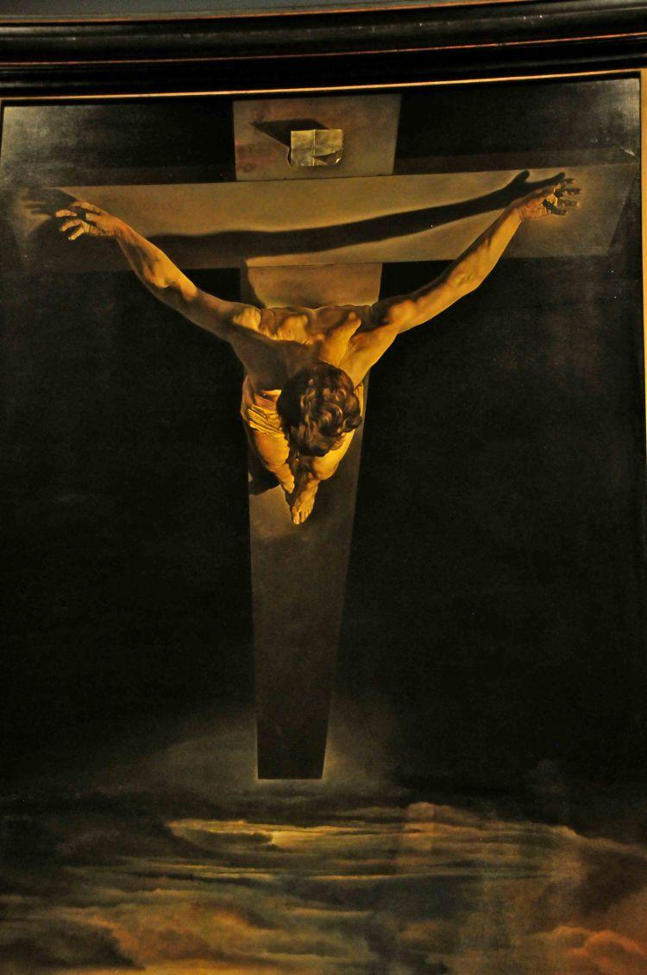
https://www.ncbi.nlm.nih.gov/pmc/articles/PMC1420788/
https://www.ncbi.nlm.nih.gov/pubmed/14750495
http://www.ranker.com/list/what-it-feels-like-to-be-crucified/jeffrichard

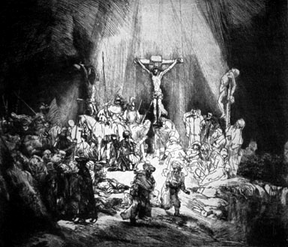

It seems rather grisly to connect the crucifixion to a marriage, but I think that is precisely what John is doing with a number of ironic symbols. He says, "I am thirsty," just as he said to the Samaritan woman. He drinks sour wine, not the good wine that he provided at the wedding. He is wearing a crown, which the bridegroom would do at a Jewish wedding--but it is not a garland, it is a crown of thorns.
At his death, blood and water flow out of his side. Commentators stumble over what to do with this emphatic assertion; sometimes it is taken to mean that he clearly died, a form of medical evidence. (Though it is by no means clear--just what precisely does it mean that the blood had separated into two parts? And would most readers in the first century have understood that?) But it would be out of character for John, in his highly symbolic and theological gospel, at the very high point of the narrative, to suddenly forsake his theological mind and emphasize purely medical facts. The medical facts are there, perhaps, but are unlikely to exhaust the significance.

I think the blood and water flowing out of his side is a symbolic, pictorial fulfillment of the better wine and the living water that Jesus promised. The argument here is a bit technical, so bear with me or just skip ahead. I think we are supposed to link together most of the references to water, wine, and blood in the gospel of John; the author is careful about his symbolic references, and is not throwing out symbols willy-nilly. These all refer to the new quality of life that comes through relationship with him--more specifically, through the Spirit that he gives, as 7:37 makes clear. There is an interesting translation issue in 7:37, having to do with where punctuation is placed in the sentence (there was no punctuation at all in the original manuscripts, so where punctuation is placed is a translator's decision). Most English translations of 7:37 follow the eastern fathers: "If anyone is thirsty, let him come to me and drink. Whoever believes in me, as the scripture has said, out of his belly shall flow rivers of living water." Here the water flows from the believers. But by changing the location of the period, we have the western Fathers' understanding of the verse: "If anyone is thirsty, let him come to me. And whoever believes in me, let him drink. As the scripture has said, 'Out of his belly shall flow rivers of living water.'" In this case, water flows from Jesus, which I think is a much more natural way of understanding the passage. 7:38 clarifies that this water is referring to the Spirit that was going to come when Jesus was glorified--which in John's gospel happens on the cross, the ultimate glorification of Jesus. Only with this interpretation of 7:37 is John's emphatic insistence on the water that flowed from Jesus' side understandable (19:35--he repeats it three times). It is a physical sign of the spiritual reality that because of his death, the Spirit is now available to believers. This is the time, at least in a picture, when he provides the better wine that he promised back at the wedding of Cana, and the living water that he promised to the Samaritan woman.
In our lives, marriage is the only thing that can change a person's family after he is born. John makes it clear in several places that after the cross, the disciples are part of Jesus' family in a way that they were not before. Interestingly, Jesus mother appears in only two places in the gospel: at the wedding, and at the cross. In both places, he addresses her with the same title ("Woman", a not-entirely-common way of talking to a mother, something which commentators stumble over). At the cross, he makes a point of bringing the disciple Jesus loved (despite all the arguments over this, I still think this is John himself) and his mother together into the same family. Perhaps the most common view of Jesus' words here is that they show the extent of Jesus' love: even in his extremity, he could still think about his mother's well-being. This may be true, but I am fairly certain it does not exhaust the meaning. John is primarily thinking theologically rather than psychologically. I think what we are supposed to gather from this is that the disciple whom Jesus loves is now part of his family--just as the woman a man loves becomes a part of his family. John uses this concrete picture of changed family relations to show what is happening spiritually.

There is probably another allusion to marriage in the scene with Mary Magdalene in the garden. Once again, a garden scene with a man and a woman is a rich picture for a Jewish audience, with overtones of the original garden. Mary goes so far as to grab him and hug him (20:17), definitely overstepping the bounds of propriety. This does not mean that they had some kind of physical relationship, contra the silly speculations that have recently become popular; but the text really does have hints of something romantic. I think that John is using the suggestive image to point out that Jesus and Mary now have a kind of relationship which in some ways is a marriage (though not a physical marriage), a relationship which they did not have before the cross. In the next verse, he calls his disciples "my brothers" and he calls God "your father"; never before had he done either of these in the gospel of John. It is only after the cross that they are his brothers, and they have a common father in this sense--they have been brought into Jesus' family.

Finally, the gospel concludes with Jesus asking Peter if he loves him. This is the only suitable attitude if we are the bride of Christ.
Posted by Gary Holt at 9:24 PM

Imparted or Imputed Righteousness? Augustine vs Luther
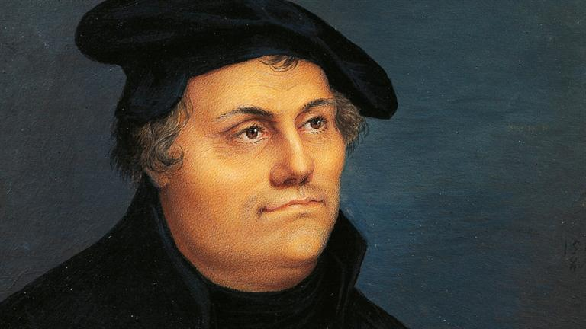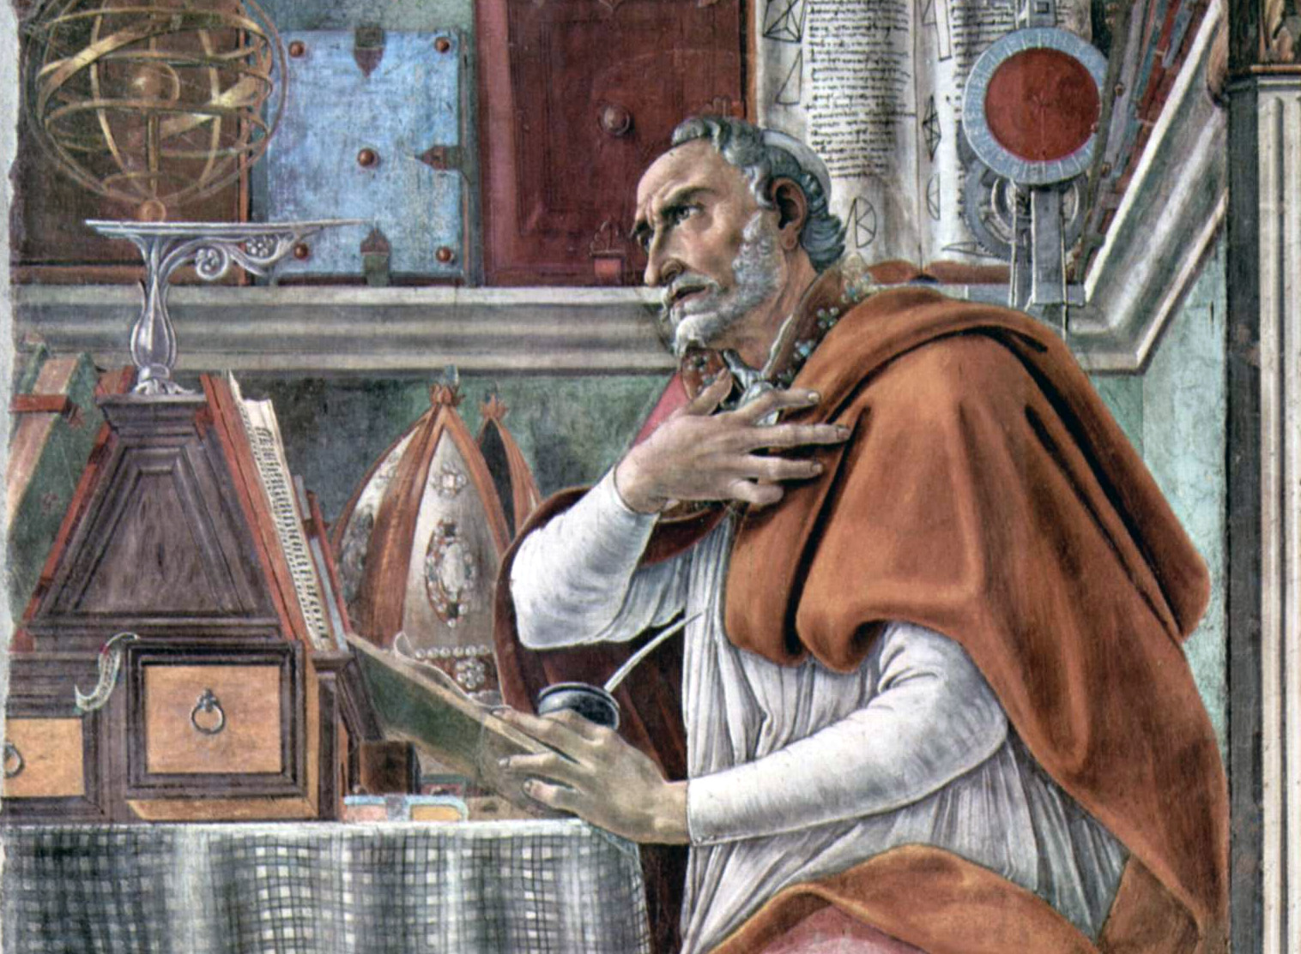
Thematic continuity in 1 John
That which was from the beginning.. heard, seen, looked upon, toouched
Walk in the light
Loeve one another, love not the world
5 You know that he appeared in order to take away sins, and in him there is no sin. 6 No one who abides in him keeps on sinning; no one who keeps on sinning has either seen him or known him. 7 Little children, let no one deceive you. Whoever practices righteousness is righteous, as he is righteous. 8 Whoever makes a practice of sinning is of the devil, for the devil has been sinning from the beginning. The reason the Son of God appeared was to destroy the works of the devil. 9 No one born of God makes a practice of sinning, for God's[b] seed abides in him; and he cannot keep on sinning, because he has been born of God. 10 By this it is evident who are the children of God, and who are the children of the devil: whoever does not practice righteousness is not of God, nor is the one who does not love his brother.

Love One Another
11 For this is the message that you have heard from the beginning, that we should love one another. 12 We should not be like Cain, who was of the evil one and murdered his brother. And why did he murder him? Because his own deeds were evil and his brother's righteous. 13 Do not be surprised, brothers,[c] that the world hates you. 14 We know that we have passed out of death into life, because we love the brothers. Whoever does not love abides in death. ……...16 By this we know love, that he laid down his life for us, and we ought to lay down our lives for the brothers. 17 But if anyone has the world's goods and sees his brother in need, yet closes his heart against him, how does God's love abide in him? 18 Little children, let us not love in word or talk but in deed and in truth.
7 Beloved, let us love one another, for love is from God, and whoever loves has been born of God and knows God. 8 Anyone who does not love does not know God, because God is love. 9 In this the love of God was made manifest among us, that God sent his only Son into the world, so that we might live through him. 10 In this is love, not that we have loved God but that he loved us and sent his Son to be the propitiation for our sins. 11 Beloved, if God so loved us, we also ought to love one another. 12 No one has ever seen God; if we love one another, God abides in us and his love is perfected in us.

17 By this is love perfected with us, so that we may have confidence for the day of judgment, because as he is so also are we in this world.18 There is no fear in love, but perfect love casts out fear. For fear has to do with punishment, and whoever fears has not been perfected in love.

Orthodoxy ⇔ Orthopraxy

What John means by ‘believe’ 



Conclusions :
Is there support for the atonement as the centre of the Scriptural message?
What Old Testament teachings anticipate the sacrifice of God’s beloved Son.
How are we to understand the nature of his death and resurrection?
What theories of the atonement are scripturally valid?
Given that the scriptural metaphors for covenant renewal with repentant sinners are adoption, redemption, and marriage, what is the kind of response to which God calls us in the Gospel?



Sin – not just being bad , naughty, or dispeasing to you or me
Not just being self-centered

Image of God – reason, emotion, free will, none of these are the core.
Representatives of God within creation.

Nebuchadnessar – images throughout the land of his rule- demarcate the extent of his kingdom
Honour the image and you worship the Emperor

Sons and Daughters – Cain, Abel, Seth, -- in the image of Adam and Eve.

Creator God – be fruitful and x and fill the earth and subdue it– living images are depictions of a living God creative, ordering
Rabbinical story – the animals see Adam –mistake him for God

Near and Dear to his heart, crown of creation, his holy priesthood – till and keep the garden are priestly words. Made for loving, like-minded, adoring, respecting relationship.
Honour is next to his own. To harm another human being, is to violate God. No killing of animals is punished by death, but

Surely I will require your lifeblood; from every beast I will require it. And from every man, from every man's brother I will require the life of man.6"Whoever sheds man's blood, By _ man his bloodshall be shed, For in the image of God He made man.

11For the life of a creature is in the blood, and I have given it to you to make atonement for yourselves on the altar; it is the blood that makes atonement for one’s life.c

for the life of the body is in its blood. I have given you the blood on the altar to purify you, making you right with the LORD. It is the blood, given in exchange for a life, that makes purification possible. NLT

